**Section 11: Leveraging the AWS Global Infrastructure:**

* + 1. **Why Global Applications?**

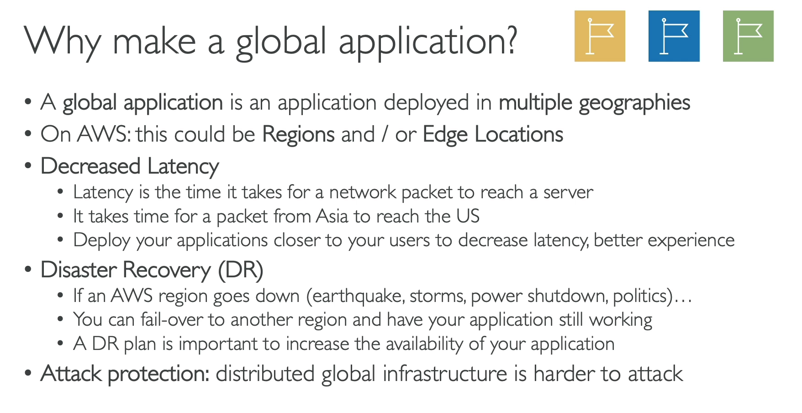

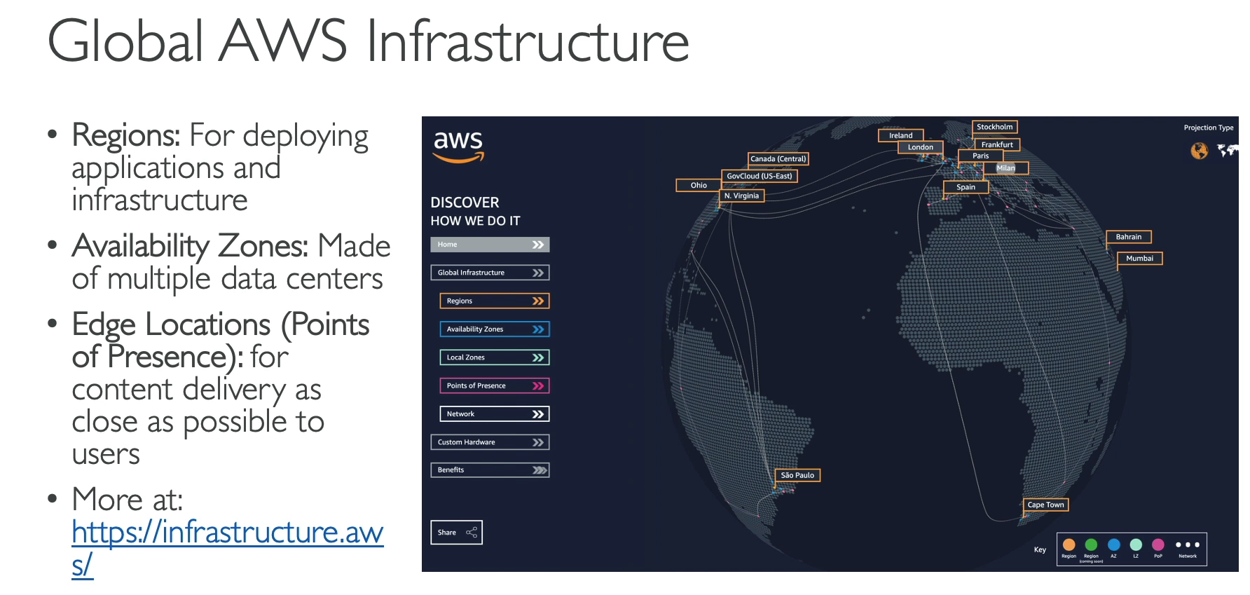

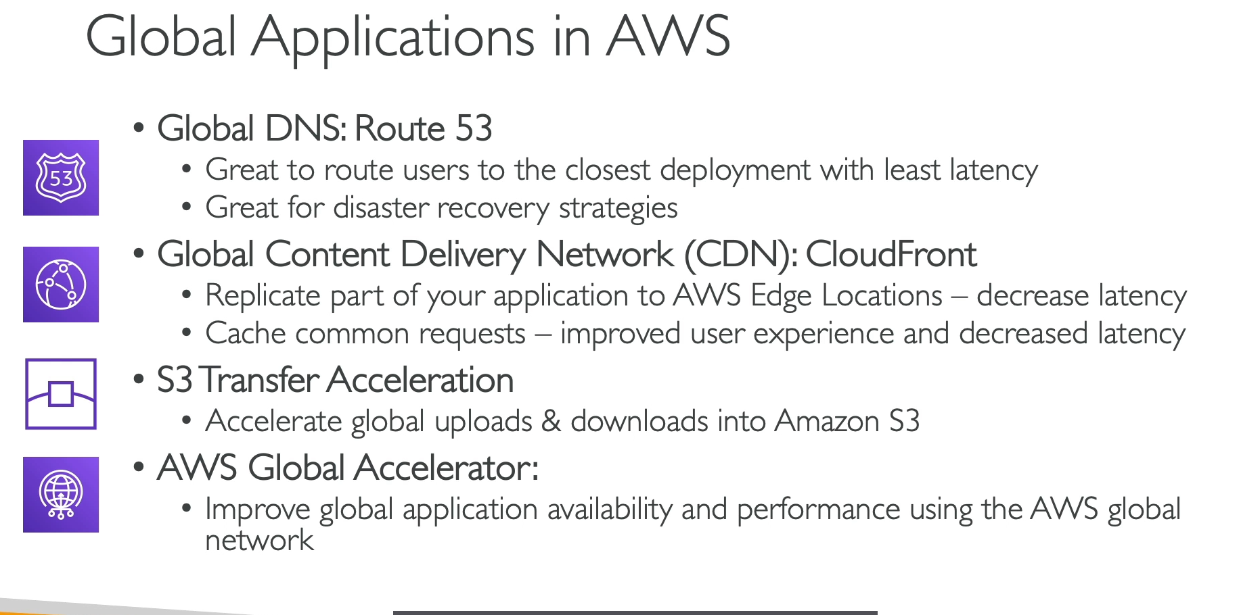

Based on the provided text, here is a summary of the reasons for creating a global application and the AWS services that support this strategy.

**Why Build a Global Application?**

* **Decreased Latency:** By deploying your application closer to your users in different geographic locations (AWS Regions), you can significantly reduce the time it takes for a user's request to reach the server. This provides a faster and more responsive user experience.
* **Disaster Recovery (DR):** Deploying your application in multiple regions ensures that if a natural disaster, power outage, or other major event affects one entire region, your application can failover to another region and remain operational. This is crucial for increasing the overall availability and resilience of your application.
* **Protection Against Attacks:** Distributing your application across multiple regions makes it more difficult for a hacker or malicious actor to launch a coordinated attack that takes down your entire service. This provides an additional layer of security.

**Core AWS Global Infrastructure**

* **Regions:** These are geographically distinct locations where AWS clusters its data centers. Each region is a fully isolated physical area. This is where you deploy your main applications and infrastructure (EC2, S3, etc.).
* **Availability Zones (AZs):** Each region consists of multiple, isolated, and physically separate data centers called AZs. They are close enough for low-latency connections but far enough apart to be protected from a single disaster affecting a region.
* **Edge Locations (Points of Presence):** These are strategically located data centers around the world that are closer to end-users. They are primarily used for caching content and are not places where you deploy your own applications. They are used by services like CloudFront.
* **AWS Global Network:** AWS has a private, global network that connects all of its regions, AZs, and Edge Locations. This proprietary network provides fast and reliable connections between AWS services worldwide.

**Key AWS Global Services**

The lecture introduces four main services that help build a global application:

* **Route 53:** AWS's **Global DNS service**. It intelligently routes users to the correct application endpoint, often based on their geographic location, to minimize latency. It is also a key component for implementing disaster recovery strategies.
* **CloudFront:** AWS's **Content Delivery Network (CDN)**. It uses the global network of **Edge Locations** to cache static and dynamic content closer to users, reducing latency and offloading traffic from your main application servers.
* **S3 Transfer Acceleration:** This service helps to **accelerate file uploads and downloads to and from an S3 bucket** by leveraging CloudFront's global network of edge locations.
* **AWS Global Accelerator:** This service uses the AWS global network to **improve the availability and performance of your applications**. It routes traffic to your application endpoints in multiple regions and continuously monitors the health of those endpoints to ensure users are always directed to the best available one.
  + 1. **Route 53 Overview:**

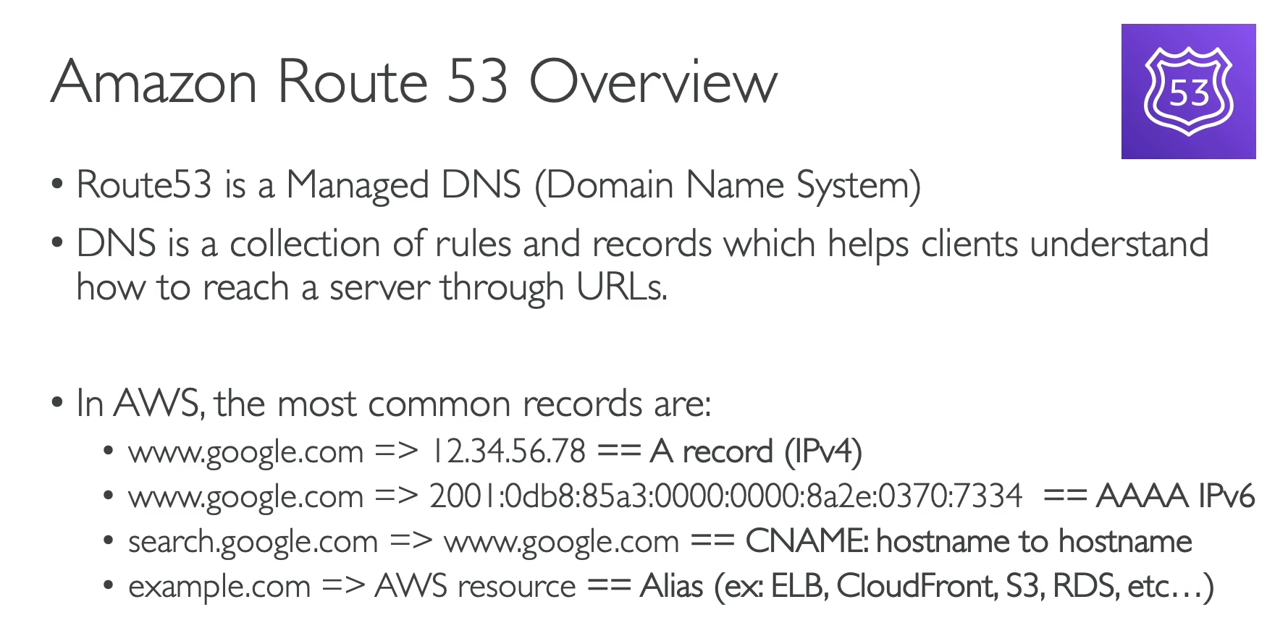

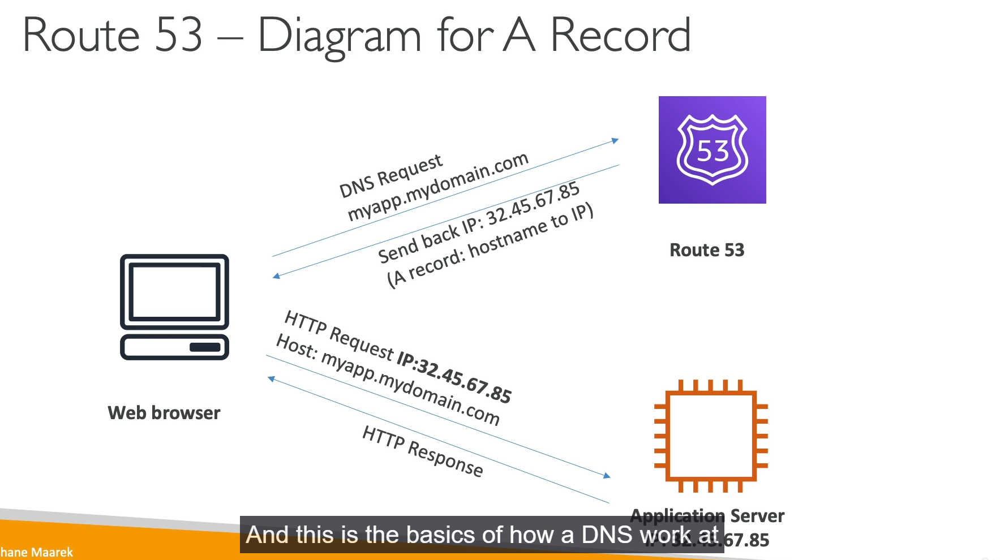

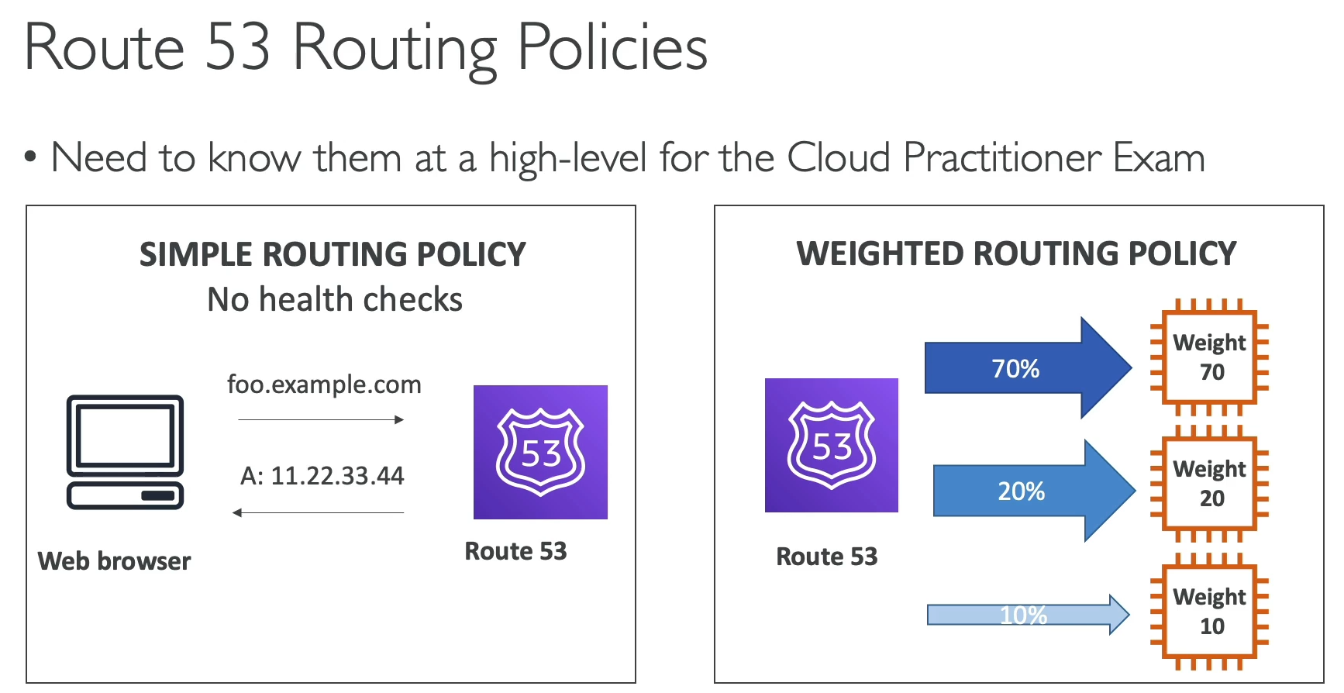

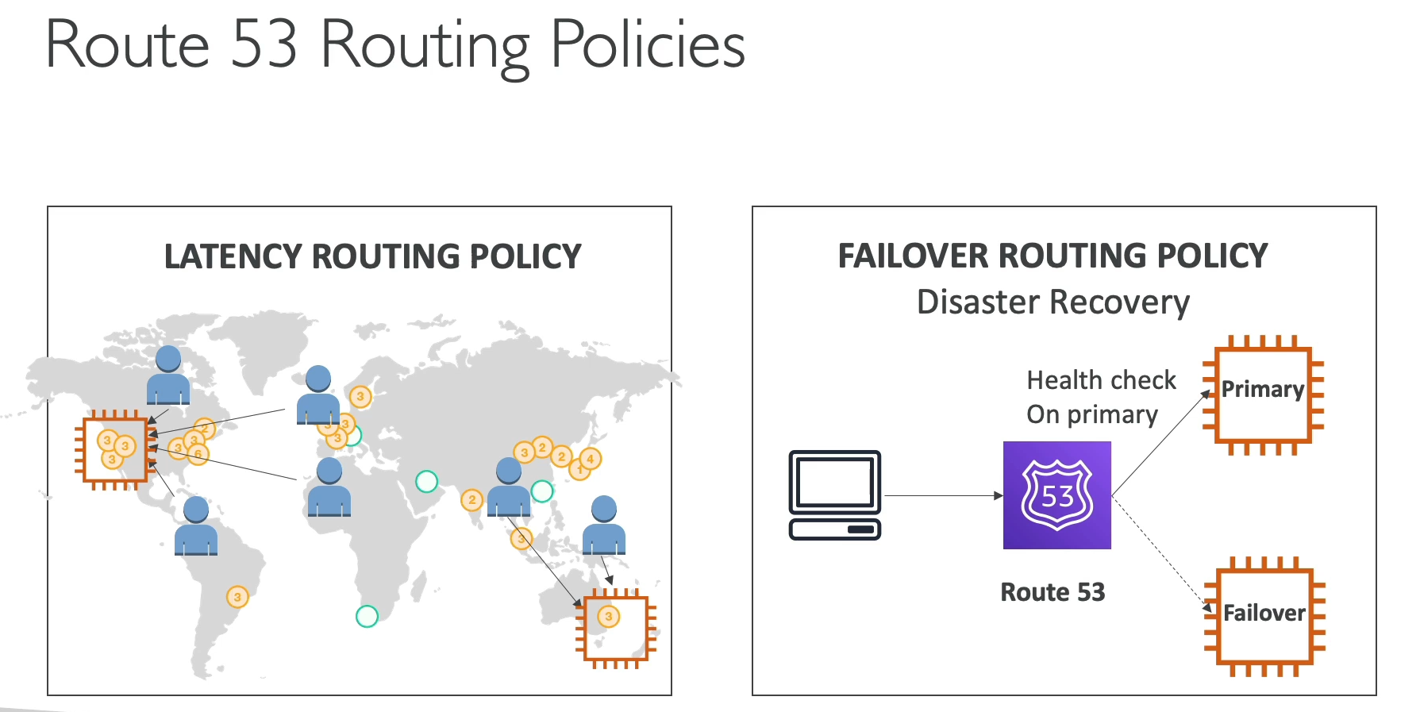

**Amazon Route 53 (Managed DNS)**

* **Purpose:** Amazon Route 53 is a highly available and scalable **managed Domain Name System (DNS) web service**. It translates human-readable domain names (like www.example.com) into the IP addresses of servers. It acts as the "phone book" of the internet.
* **Key Record Types:** The text highlights four main record types. While not all are critical for the exam, understanding the basics is useful:
  + **A Record:** Maps a domain name to an **IPv4 address**.
  + **AAAA Record:** Maps a domain name to an **IPv6 address**.
  + **CNAME:** Maps a domain name to **another domain name**.
  + **Alias Record:** A special Route 53-specific record that maps a domain name to a **specific AWS resource** (e.g., an Elastic Load Balancer, CloudFront distribution, or S3 bucket). Unlike a CNAME, an Alias can be used for the root domain (e.g., mydomain.com).

**Route 53 Routing Policies**

Route 53 offers different routing policies to control how traffic is routed to your resources. For the exam, it's essential to understand the purpose of each one.

* **Simple Routing Policy:**
  + **Use Case:** The most basic routing policy. It routes all traffic to a single resource.
  + **Health Checks:** It does **not** support health checks. If the resource goes down, traffic will still be sent to it.
* **Weighted Routing Policy:**
  + **Use Case:** To distribute traffic to multiple resources in different proportions. You can set a "weight" for each resource (e.g., 70% to one server, 30% to another). This is useful for A/B testing or rolling out new versions of an application.
  + **Health Checks:** **Supports** health checks. If a resource becomes unhealthy, Route 53 will stop sending traffic to it.
* **Latency Routing Policy:**
  + **Use Case:** To route traffic to the resource that provides the **lowest latency** for the user. It is the primary tool for building a global application that serves users from the closest possible region.
  + **Health Checks:** **Supports** health checks. It will not route traffic to an unhealthy resource, even if it has the lowest latency.
* **Failover Routing Policy:**
  + **Use Case:** For **disaster recovery (DR)**. You configure a primary resource and a secondary (failover) resource. All traffic is routed to the primary resource unless it fails a health check, at which point all traffic is automatically rerouted to the secondary.
  + **Health Checks:** **Relies heavily on health checks** to determine when to fail over to the secondary resource.

**Exam Takeaway**

* **Route 53 is a managed DNS.**
* **DNS is a "phone book"** that translates domain names to IP addresses.
* **Routing policies are critical:**
  + **Simple:** Basic routing, no health checks.
  + **Weighted:** Distribute traffic in specific proportions.
  + **Latency:** Minimize latency for global applications.
  + **Failover:** Implement disaster recovery and high availability.
* **Alias Records** are special to AWS resources and are a common exam topic.
  + 1. **Route 53 Hands On:**

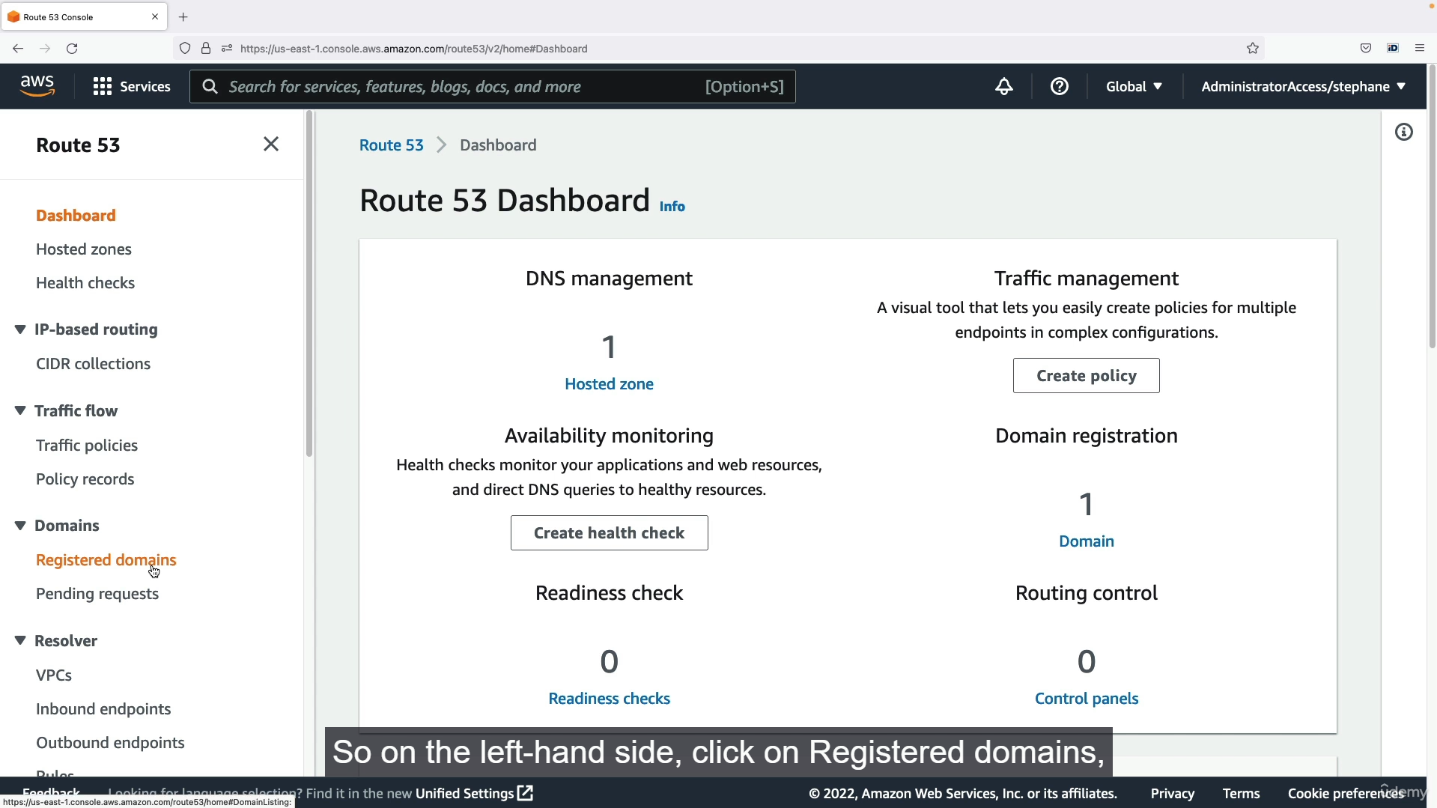

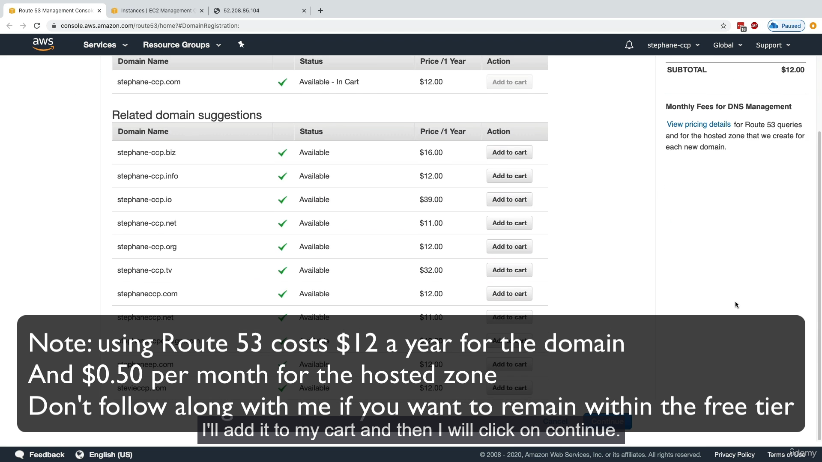

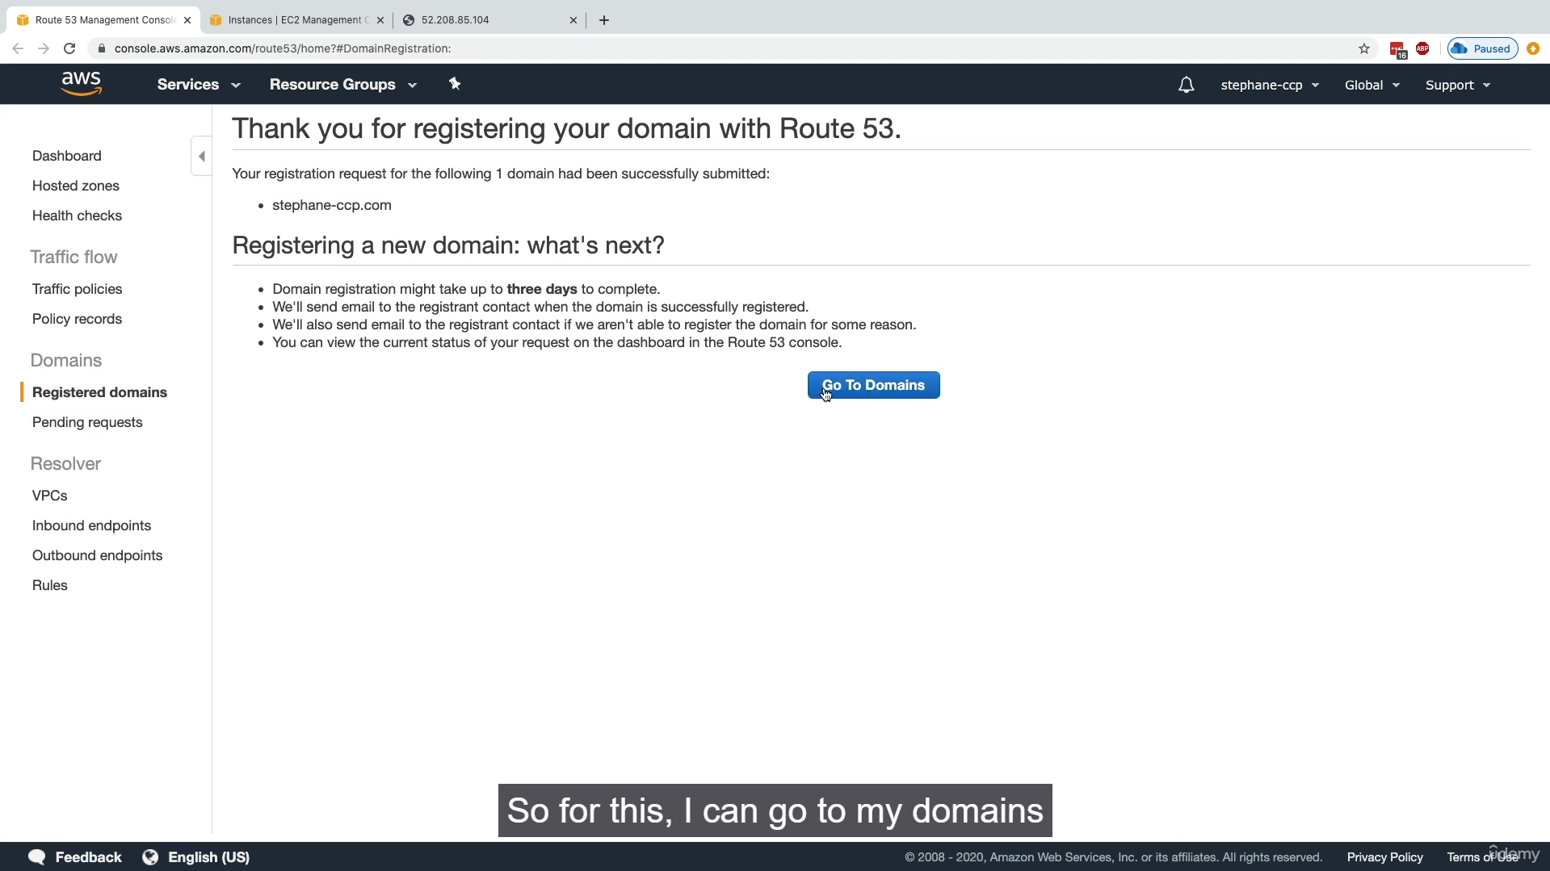

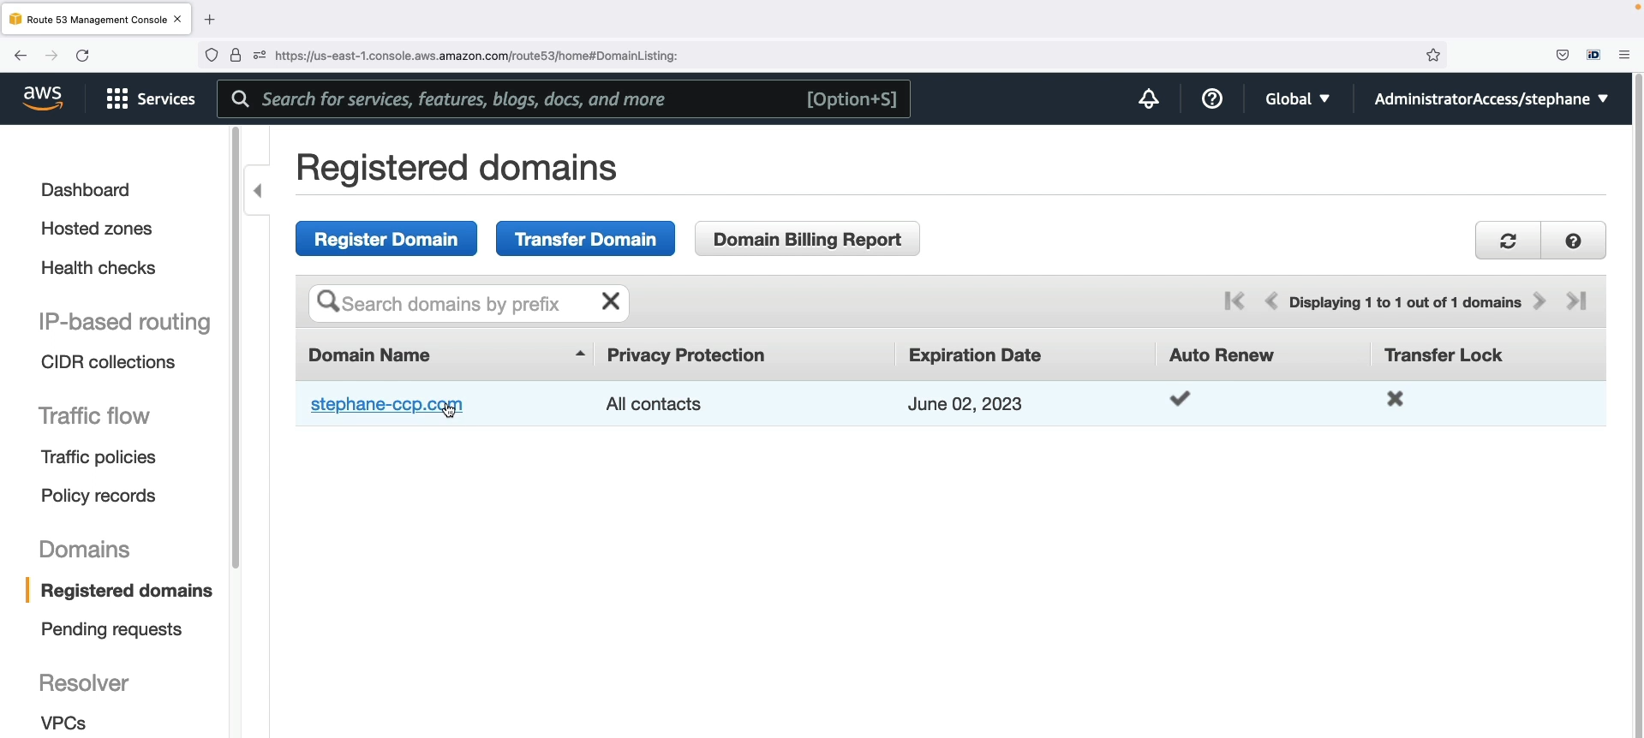

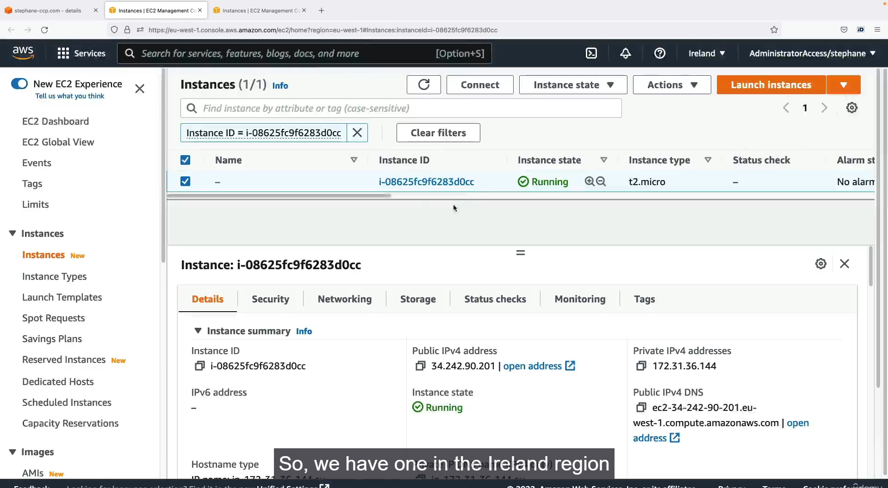

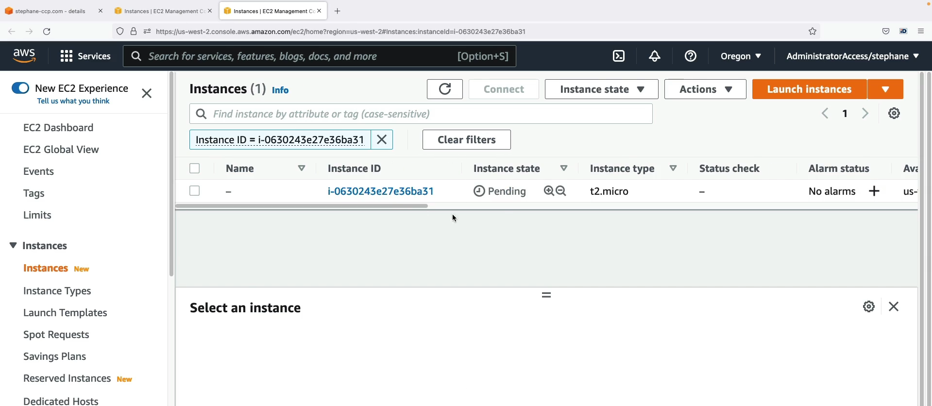

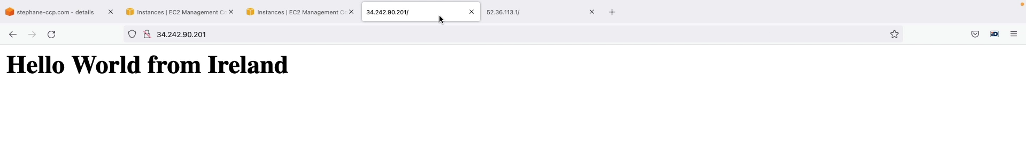

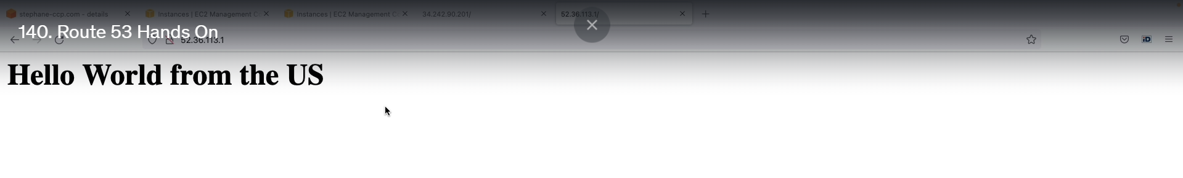

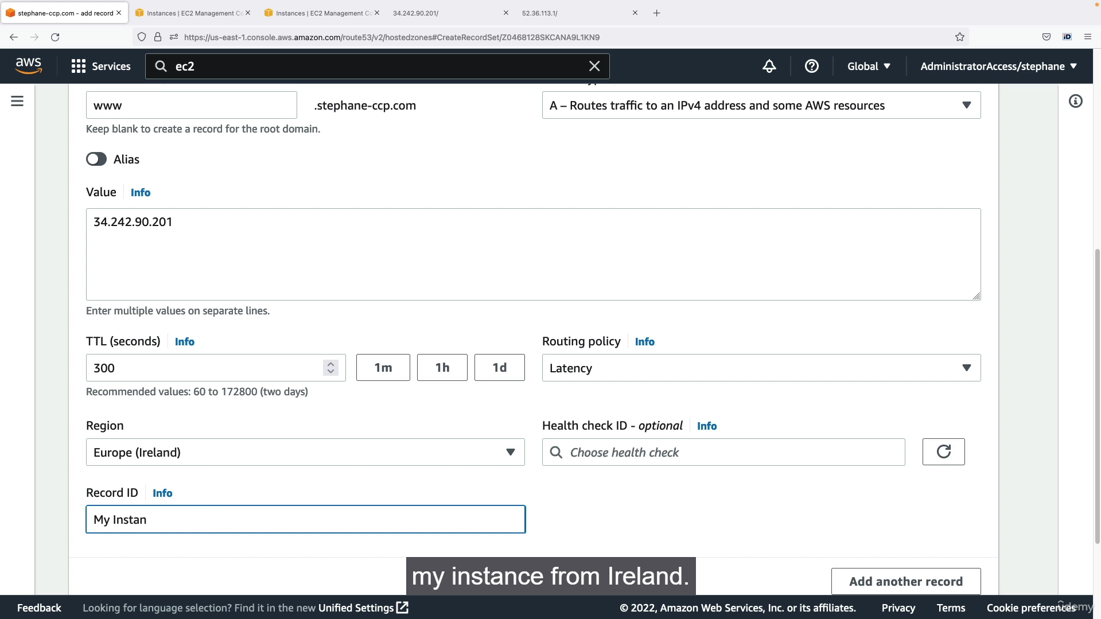

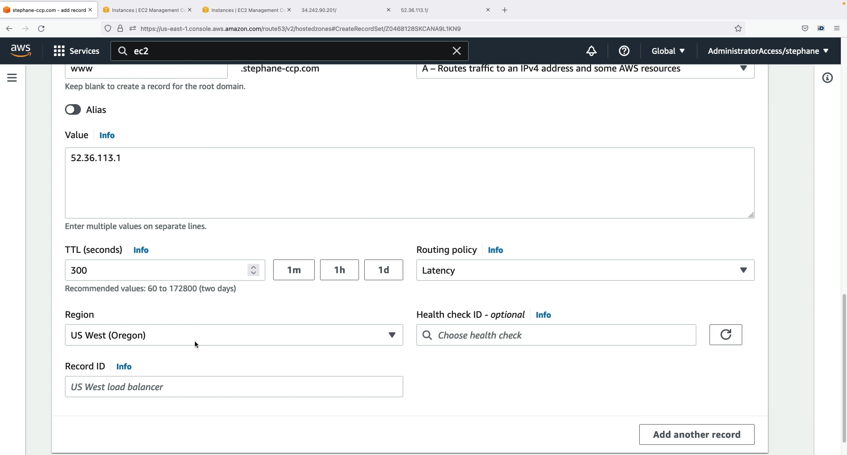

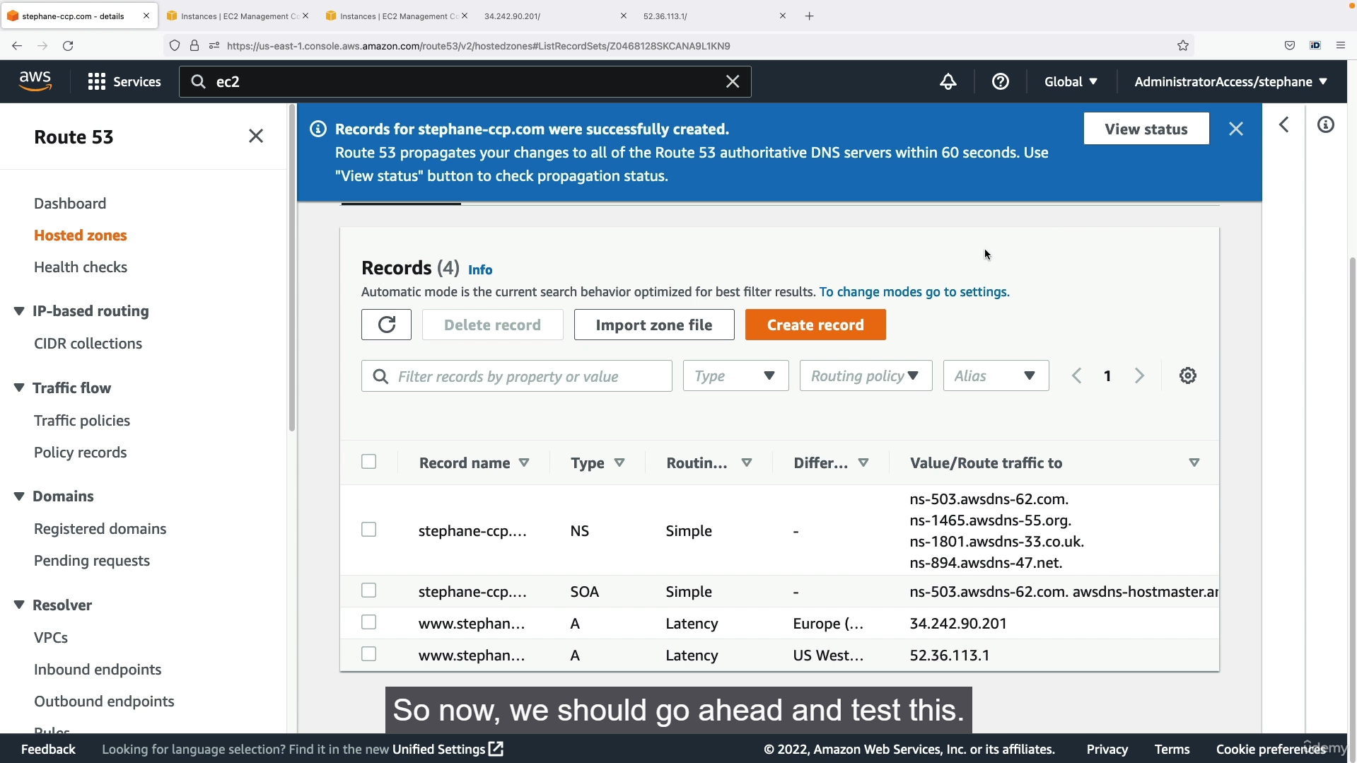

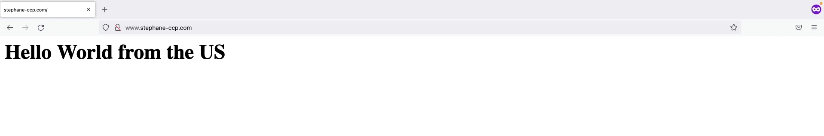

**Step 1: Register a Domain and Create a Hosted Zone**

1. Navigate to the **Route 53** console.
2. Click **"Registered domains"** in the left navigation pane.
3. Click **"Register Domain"** and choose a domain name (e.g., stephane-ccp.com).
4. Follow the steps to purchase the domain. This will incur a cost.
5. After the domain is purchased, Route 53 will automatically create a **Hosted Zone** for it. You can view this hosted zone by clicking on "Hosted zones" in the left pane.

**Step 2: Launch EC2 Instances in Different Regions**

1. Go to the **EC2 console**.
2. Change your region to **EU-West (Ireland)**.
3. Launch a new EC2 instance.
   * Choose an instance type (e.g., T2.micro).
   * Create a new security group that allows inbound **HTTP traffic** (port 80).
   * Under "Advanced details," add the following **user data** script to automatically set up a web server:

Bash

#!/bin/bash

yum update -y

yum install -y httpd

systemctl start httpd

systemctl enable httpd

echo "Hello world from Ireland" > /var/www/html/index.html

* + Launch the instance and note its **Public IPv4 address**.

1. Change your region to **US-West-2 (Oregon)**.
2. Launch another EC2 instance, repeating the same steps as above, but with the user data script changed to:

Bash

#!/bin/bash

yum update -y

yum install -y httpd

systemctl start httpd

systemctl enable httpd

echo "Hello world from the US" > /var/www/html/index.html

1. Note the **Public IPv4 address** of this second instance.

**Step 3: Configure Latency-Based Routing in Route 53**

1. Return to the **Route 53 console** and navigate to your Hosted Zone (e.g., stephane-ccp.com).
2. Click **"Create record."**
3. Configure the first record for your **European instance**:
   * **Record name:** www (this will create www.stephane-ccp.com).
   * **Record type:** **A** (to map a domain name to an IPv4 address).
   * **Value:** Paste the **Public IPv4 address** of the EC2 instance in Ireland.
   * **Routing policy:** Select **"Latency."**
   * **Region:** Select **"EU (Ireland)."**
   * **Record ID:** Provide a unique name (e.g., My Ireland Instance).
4. Add a second record for your **US instance** by clicking **"Add another record."**
   * **Record name:** www (this must be the same as the first record).
   * **Record type:** **A**.
   * **Value:** Paste the **Public IPv4 address** of the EC2 instance in Oregon.
   * **Routing policy:** Select **"Latency."**
   * **Region:** Select **"US West (Oregon)."**
   * **Record ID:** Provide a unique name (e.g., My US Instance).
5. Click **"Create records."**

**Step 4: Test the Latency-Based Routing**

1. Open a new browser tab and navigate to your domain (e.g., http://www.stephane-ccp.com).
2. The page should display **"Hello world from Ireland"** because your current location has less latency to the EU-West region.
3. Connect to a **VPN** and set your location to the **United States**.
4. Open a new incognito or private browser window and navigate to the same domain again.
5. The page should now display **"Hello world from the US,"** demonstrating that Route 53 correctly routed your request to the EC2 instance with the lowest latency based on your new, perceived location.

**Step 5: Clean Up**

1. To avoid ongoing costs, go back to the EC2 console and **terminate both EC2 instances** in their respective regions.
2. (Optional) If you want to delete the hosted zone, go to Route 53, select the hosted zone, and click **"Delete Hosted Zone."**
3. To avoid the annual domain registration fee, disable auto-renewal for your domain in the Route 53 "Registered domains" section.
   * 1. **CloudFront Overview:**

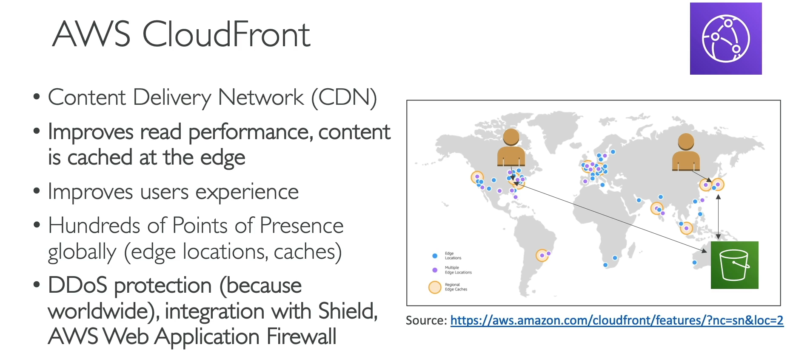

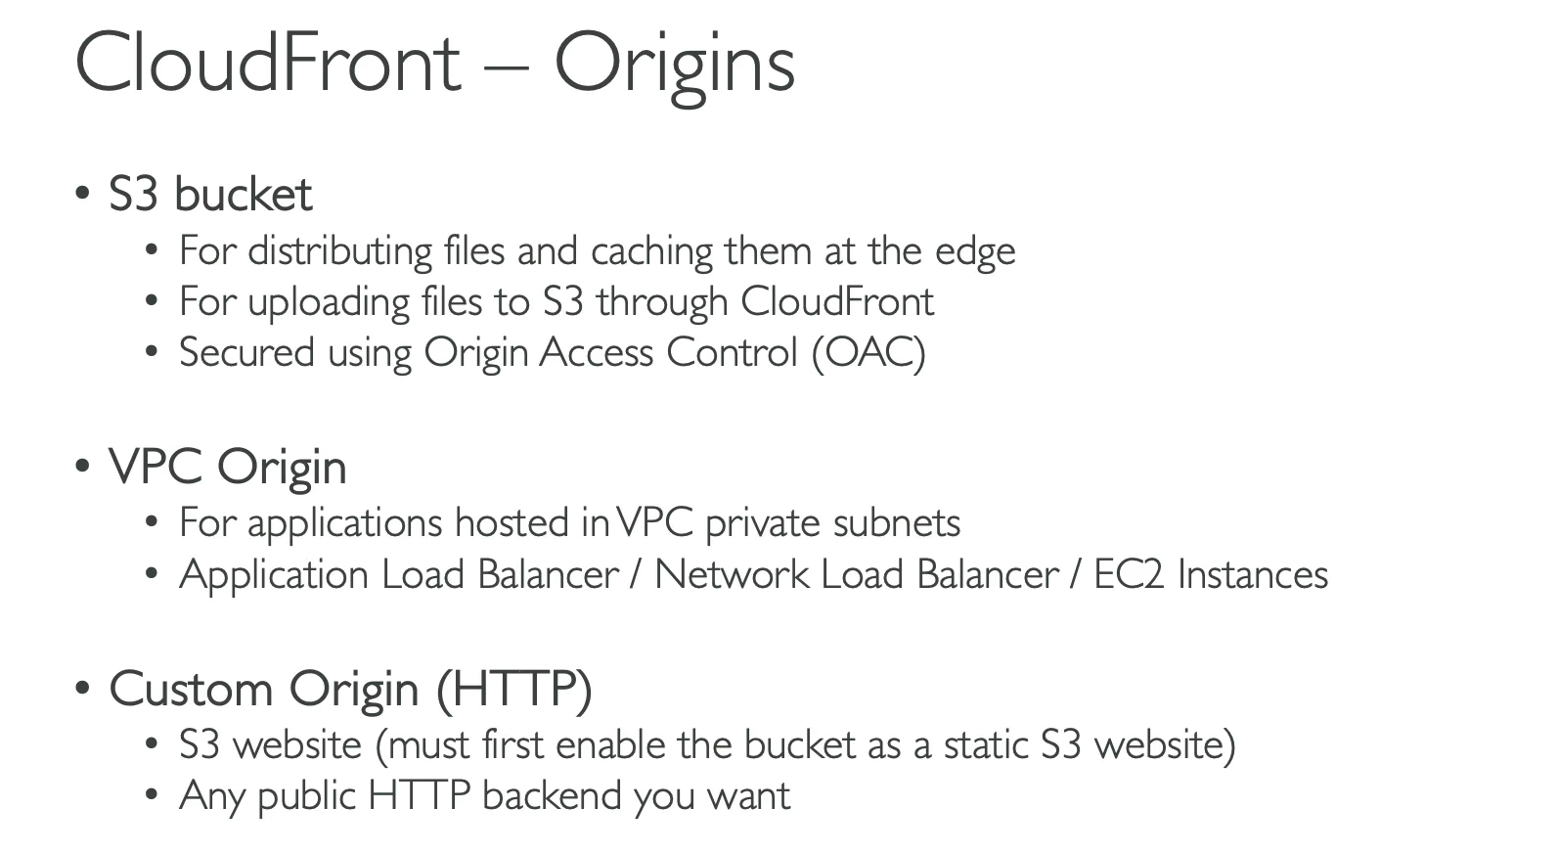

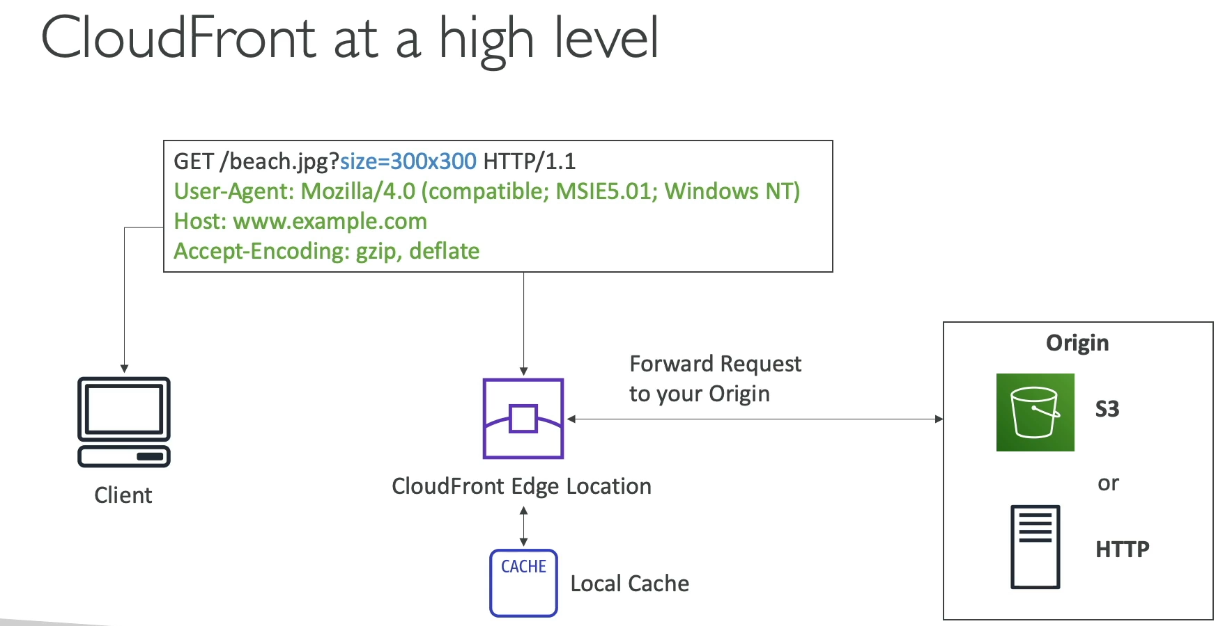

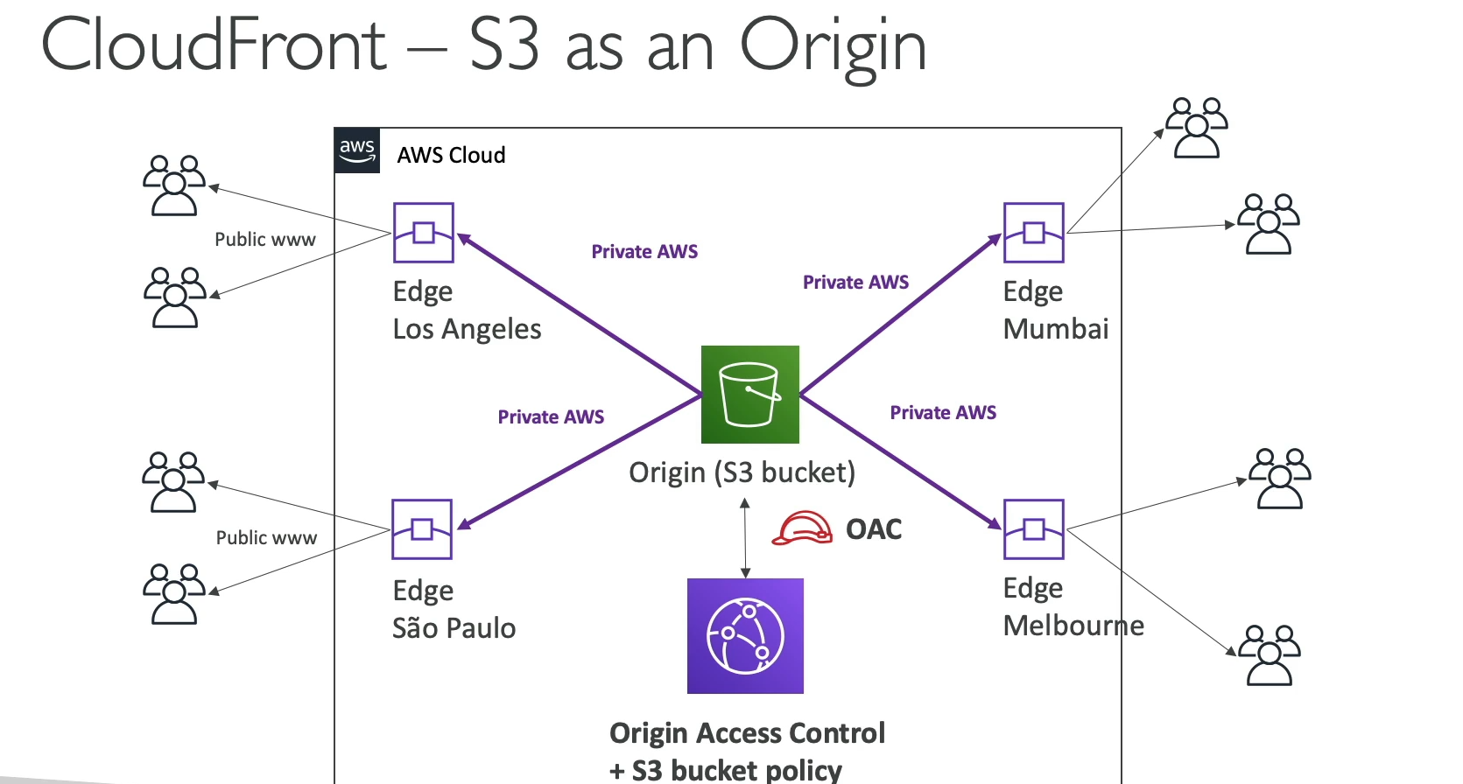

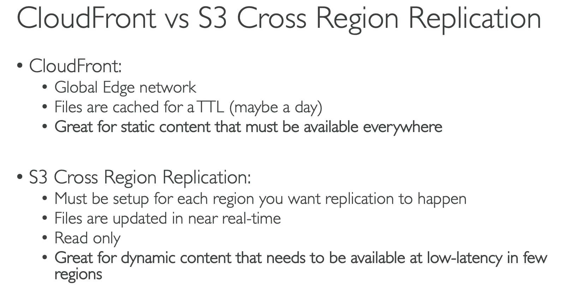

**AWS CloudFront (Content Delivery Network)**

* **Purpose:** CloudFront is a **Content Delivery Network (CDN)** that accelerates the delivery of web content (both static and dynamic) to users around the world. It improves application performance by caching content at geographically distributed **Edge Locations**.
* **Core Functionality:**
  + **Caching at the Edge:** CloudFront has a global network of hundreds of **Points of Presence (PoPs)** or Edge Locations. When a user requests content, it is served from the closest Edge Location. If the content isn't in the cache, CloudFront fetches it from the origin and caches it for subsequent requests.
  + **Reduced Latency:** By serving content from a location closer to the user, CloudFront drastically reduces network latency and improves the overall user experience.
  + **DDoS Protection:** CloudFront helps protect against Distributed Denial of Service (DDoS) attacks by distributing traffic and mitigating common attack vectors at the edge. It integrates with other services like AWS Shield and WAF for enhanced security.
* **CloudFront Origins (Backends):** CloudFront can be configured to deliver content from various types of origins:
  + **Amazon S3:** The most common origin for static websites and content. CloudFront can distribute files from an S3 bucket and secure the connection using an **Origin Access Control (OAC)** to prevent direct public access to the bucket.
  + **VPC:** You can connect CloudFront to a private application running in a VPC (e.g., an EC2 instance, an Elastic Load Balancer). This keeps the application private while still leveraging the CDN for content delivery.
  + **Custom Origin:** Any public HTTP server, whether on AWS or not (e.g., a website running on-premises), can be used as a custom origin.
* **CloudFront vs. S3 Cross-Region Replication:**
  + **CloudFront:** A **caching service** that uses a global network of **216+ PoPs** to deliver static and dynamic content with low latency. Caching is for a limited duration (e.g., a day). It is best for frequently accessed, unchanging content.
  + **S3 Cross-Region Replication:** A **data replication service** that copies the entire contents of an S3 bucket to another S3 bucket in a different region. The files are replicated in near real-time, and there is no caching involved. It is best for data that needs to be permanently available in multiple specific regions for disaster recovery or global data access.